Sprint 3 Report, Slug’s Bus Schedule

T.E.A.M. : Riwen Mao, Joshua Palis, Cyrus Hyett, Calvin La

# Actions to stop doing

* Last minute meeting time changes
* Pushing changes that cause errors

# Actions to start doing

* More thorough documentation in the code and in commits.
* Have a more consistent meeting schedule, so the team can make sure that everyone can attend.
* Have team members help each other more when they’re stuck with a particular bug.

# Actions to keep doing

* Consistent communication and meetings to keep us on track and on the same page.
* The team should continue to push changes often to constantly tweak and improve the code.
* Come up with new ideas for possible features or ways to optimize the application.
* The team should keep supporting each other because it helps increase moral, productivity and promotes team bonding.

# Work completed/not completed

## Completed

* I am a user, and I want to see which direction a bus is coming from/ going to, so that I know which side of the street my bus stop will be.
* I am a user, and I want to report how crowded the bus that I am currently taking is, so that other users may avoid taking this bus and thus prevent more crowding.
* I am a user and I want to see how crowded each bus is and when the status of that bus was updated, so that I may be able to choose a less crowded bus to take.
* I am a user, I want the Slug Bus Schedule application to be usable on my mobile device

## Not completed

* None

# Work completion rate

* Total number of user stories completed during the prior sprint.
  + 4 user stories
* Total number of estimated ideal work hours completed during the prior sprint.
  + 20 hr, includes both research and development
* Total number of days during the prior sprint.
  + 7 days
* For the previous sprint, the user stories/day and ideal work hours/day figures should be reported.
  + User stories per day: About 1
  + Ideal work hours per day: 5 hr.
* average user stories/day and average ideal work hours/day figures computed across all sprints to date.
  + Average story/day: 5/12
  + Hours/day: 7 hr. `

# Burnup chart

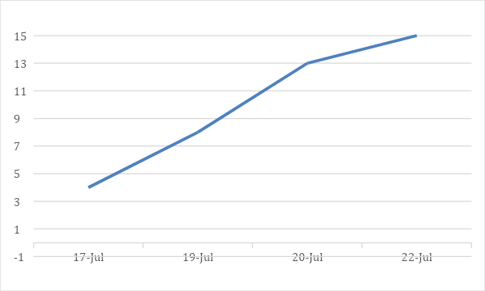

# Scrum board

|  |  |  |  |
| --- | --- | --- | --- |
| User Stories | Tasks not started | Tasks in progress | Tasks Done |
| Bus Direction |  |  | Categorize each bus by their street |
|  |  |  | Add new portion in the bus card to display what the direction the bus is coming from |
| Create option to make Crowded reports |  |  | Add new mapping table to the SQL database and create columns for the three options and bus status |
|  |  |  | Create stored procedure to update the bus status based on the number of report types within a set unit of time |
|  |  |  | Allow users to rate bus crowds for each bus card on a scale of 1 to 3, where 1 is not crowded, and 3 is crowded |
| View Bus status |  |  | Use the decided color for a bus card to display the bus card as that color across all bus stops matching the bus key. |
|  |  |  | Design Bus cards to display all the info in a simple way |
| Make application mobile friendly |  |  | Move “Find my bus” button |
|  |  |  | Utilize more responsive components of the Bootstrap framework |